

**FACULTY OF ENGINEERING AND NATURAL SCIENCES**

**ENS 209**

**INTRODUCTION TO COMPUTER AIDED DRAFTING & SOLID MODELING**

**TERM PROJECT PROGRESS REPORT**

**“WIND-UP TOY CAR”**

Prepared by:

Ufuk Ulaş Tokat 28914

Okan Arslantaş 26345

Çise Göksu Uzun 28502

Begüm Boynukısa 27052

Supervised by:

Utku Seven

**Introduction:**

The wind-up toy car is an automaton toy car that is powered by a clockwork engine (Wulffson, 2022.) Automata produced for art, entertainment, and simulation have been seen, with examples including the Heron of Alexandria creating clockwork birds during the Hellenistic Period. It is commonly said that Leonardo da Vinci invented the mechanical lion that he gave to King Francois I in France in the 16th century. The Château du Clos Lucé has a replica of this mechanism even if the original drawings are lost to time (Shirbon, 2009).

They work by storing the movement of the rotating wheels as energy in a helical spring inside the large central-toothed wheel after the car is pulled back while being pushed down. When released, it will unwind and move the car ahead. A clutch disengages once the spring has completely sprung, allowing the machine to roll free (Sorrel, 2011).

**Detailed Description of the Product:**

Wind-up toy car designs are generally formed by a body, 4 tires, at least one wind-up motor that includes a gearbox that has a minimum of 5 different gears, 2 main shafts, 1 medium shaft, coiled spring, and cosmetic parts for the aesthetic.

The wind-up toy design in this project has 12 unique parts. These are 2 bodies (upper and lower body), 5 gears, 3 motor parts, 1 coiled spring, and 1 wheel.

Polylactic acid (PLA) will be used as a material except for wheels, which were typically made of fiber cords that were woven together and coated in rubber. Whereas for 3D printing, all parts will be produced by PLA.

The detailed design of the product is as follows:

**BODIES**

Upper body is used for aesthetic reasons and it covers the motors, gears, and coiled spring. The lower body was used for shafts, which were connected wheels with motors.

1) Upper Body

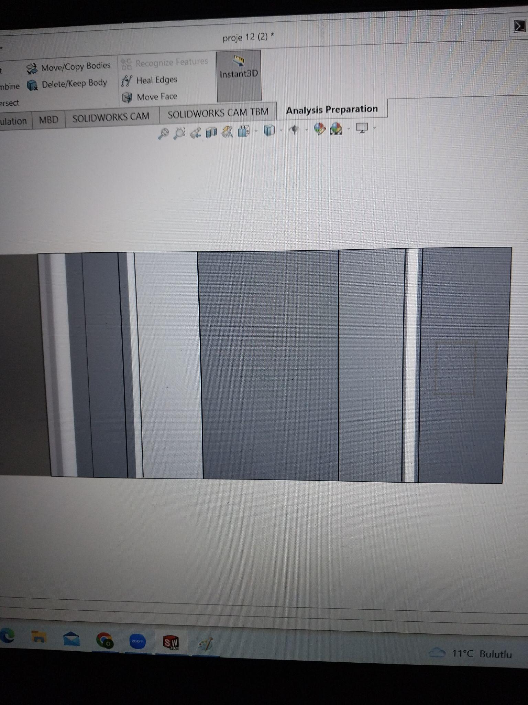

2) Lower Body

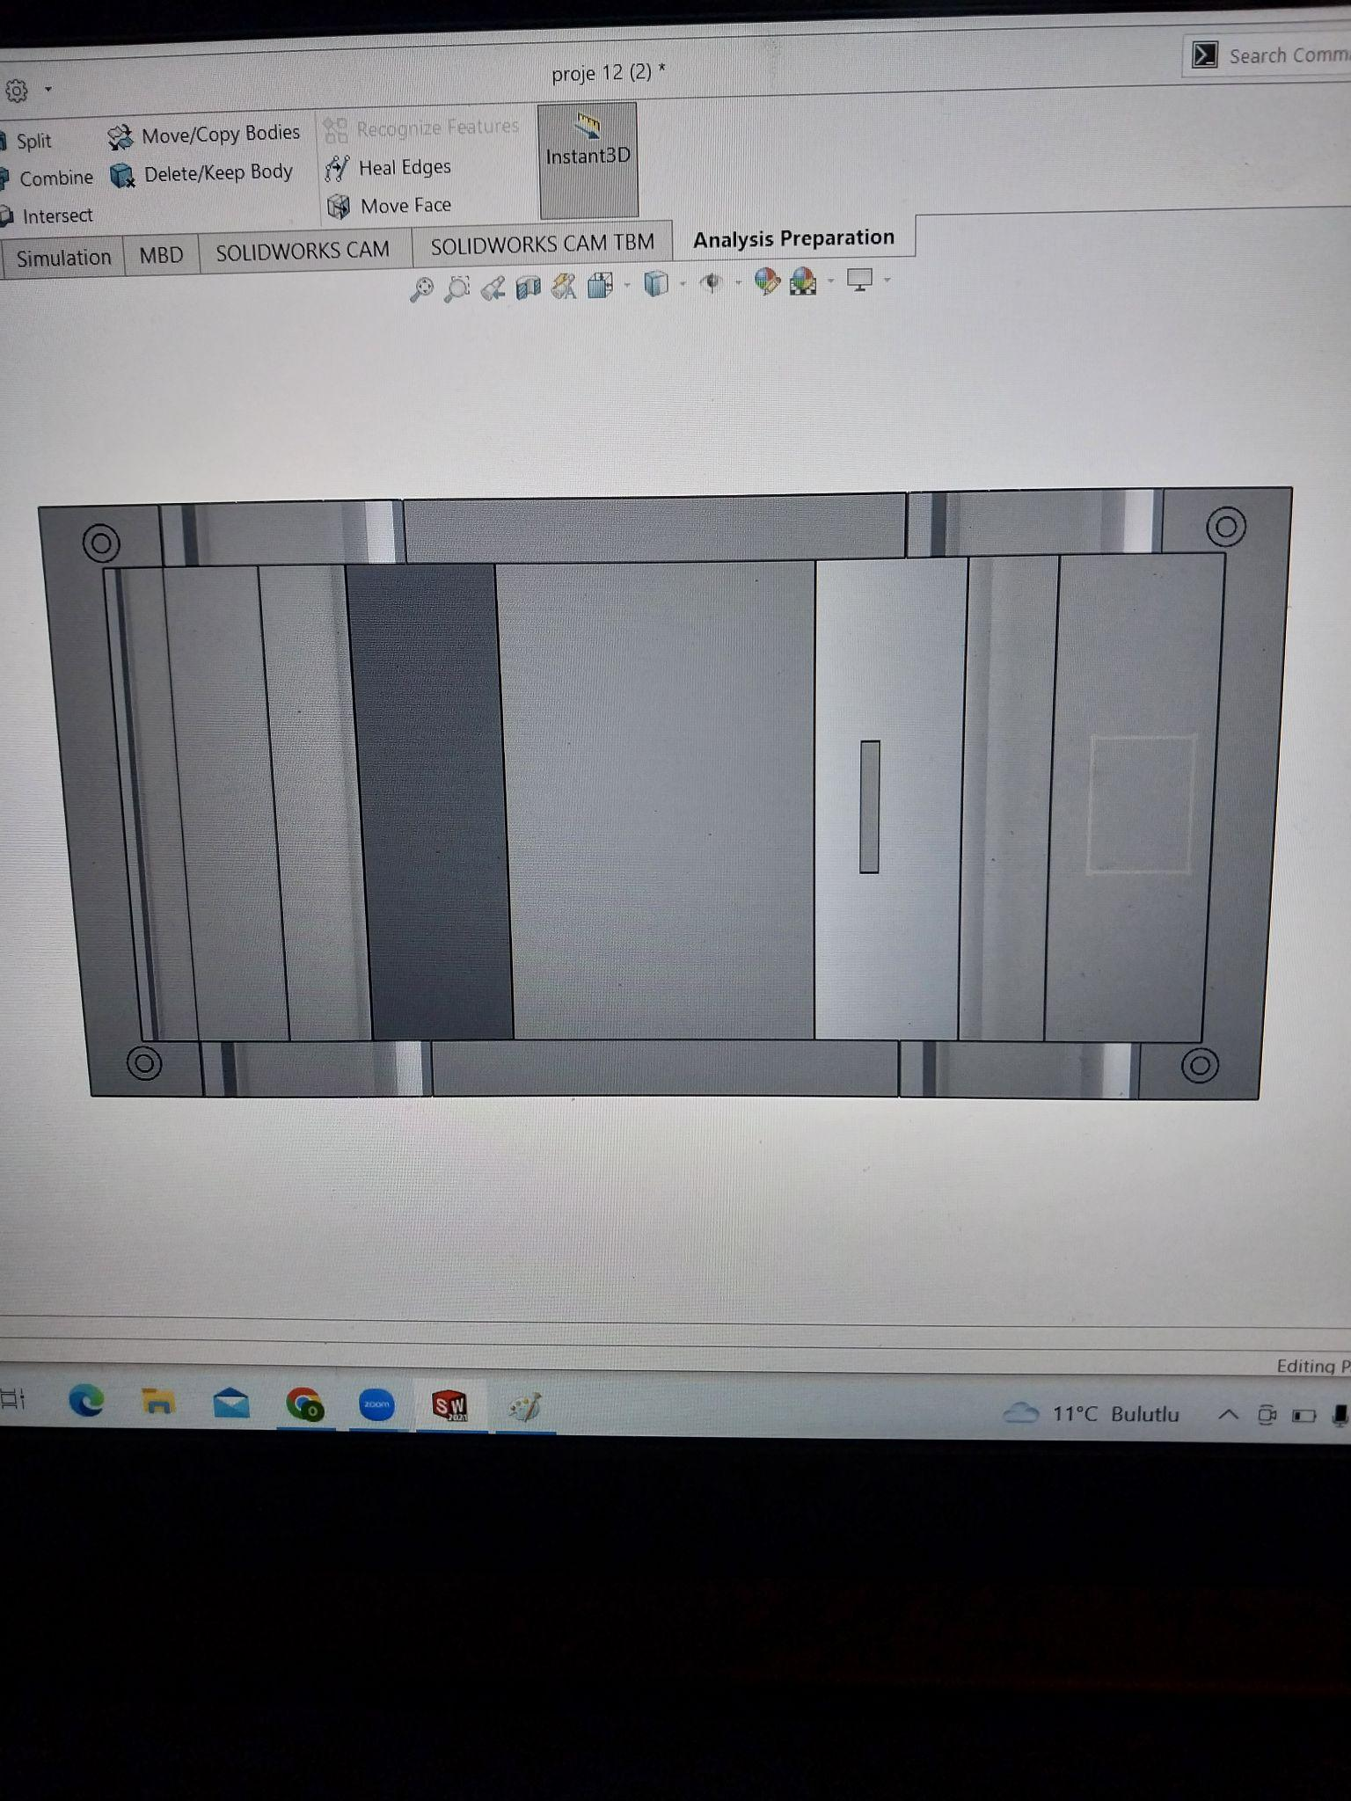

**GEARS**

Gears are used inside the motors and they transfer the energy in two ways: first (as the car is moved backward by the user) from wheels and shafts to a coiled spring; second (when energy stored inside the coiled spring due to backward motion) from coiled springs to shafts and wheels.

3-7 ) Gears (No pictures)

**MOTOR PARTS**

3 different motor parts are used to create a single big motor. These motors consist of a coiled spring and five gears. With motors and parts inside them, they shape the gearbox.

8-10) Motor parts

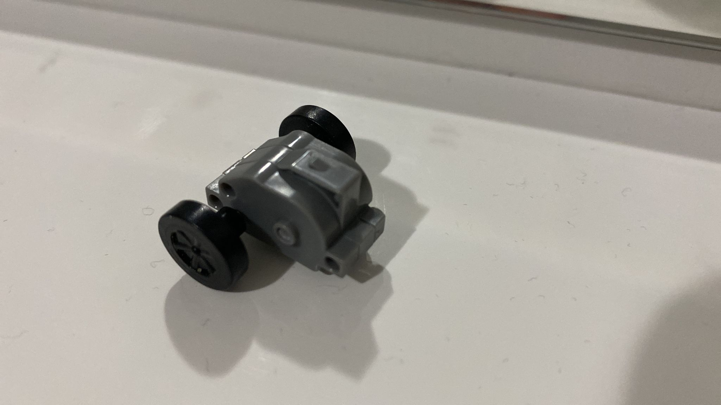

**COILED SPRING**

Coiled spring functions as energy storage and is responsible for the movement of the toy car. As someone pulls the car backward, the motion of the turning wheels is stored as energy inside the coiled spring. Then letting go of the car disengages the spring and energy stored inside the spring go back to the wheels via gears and shafts.

11) Coiled spring

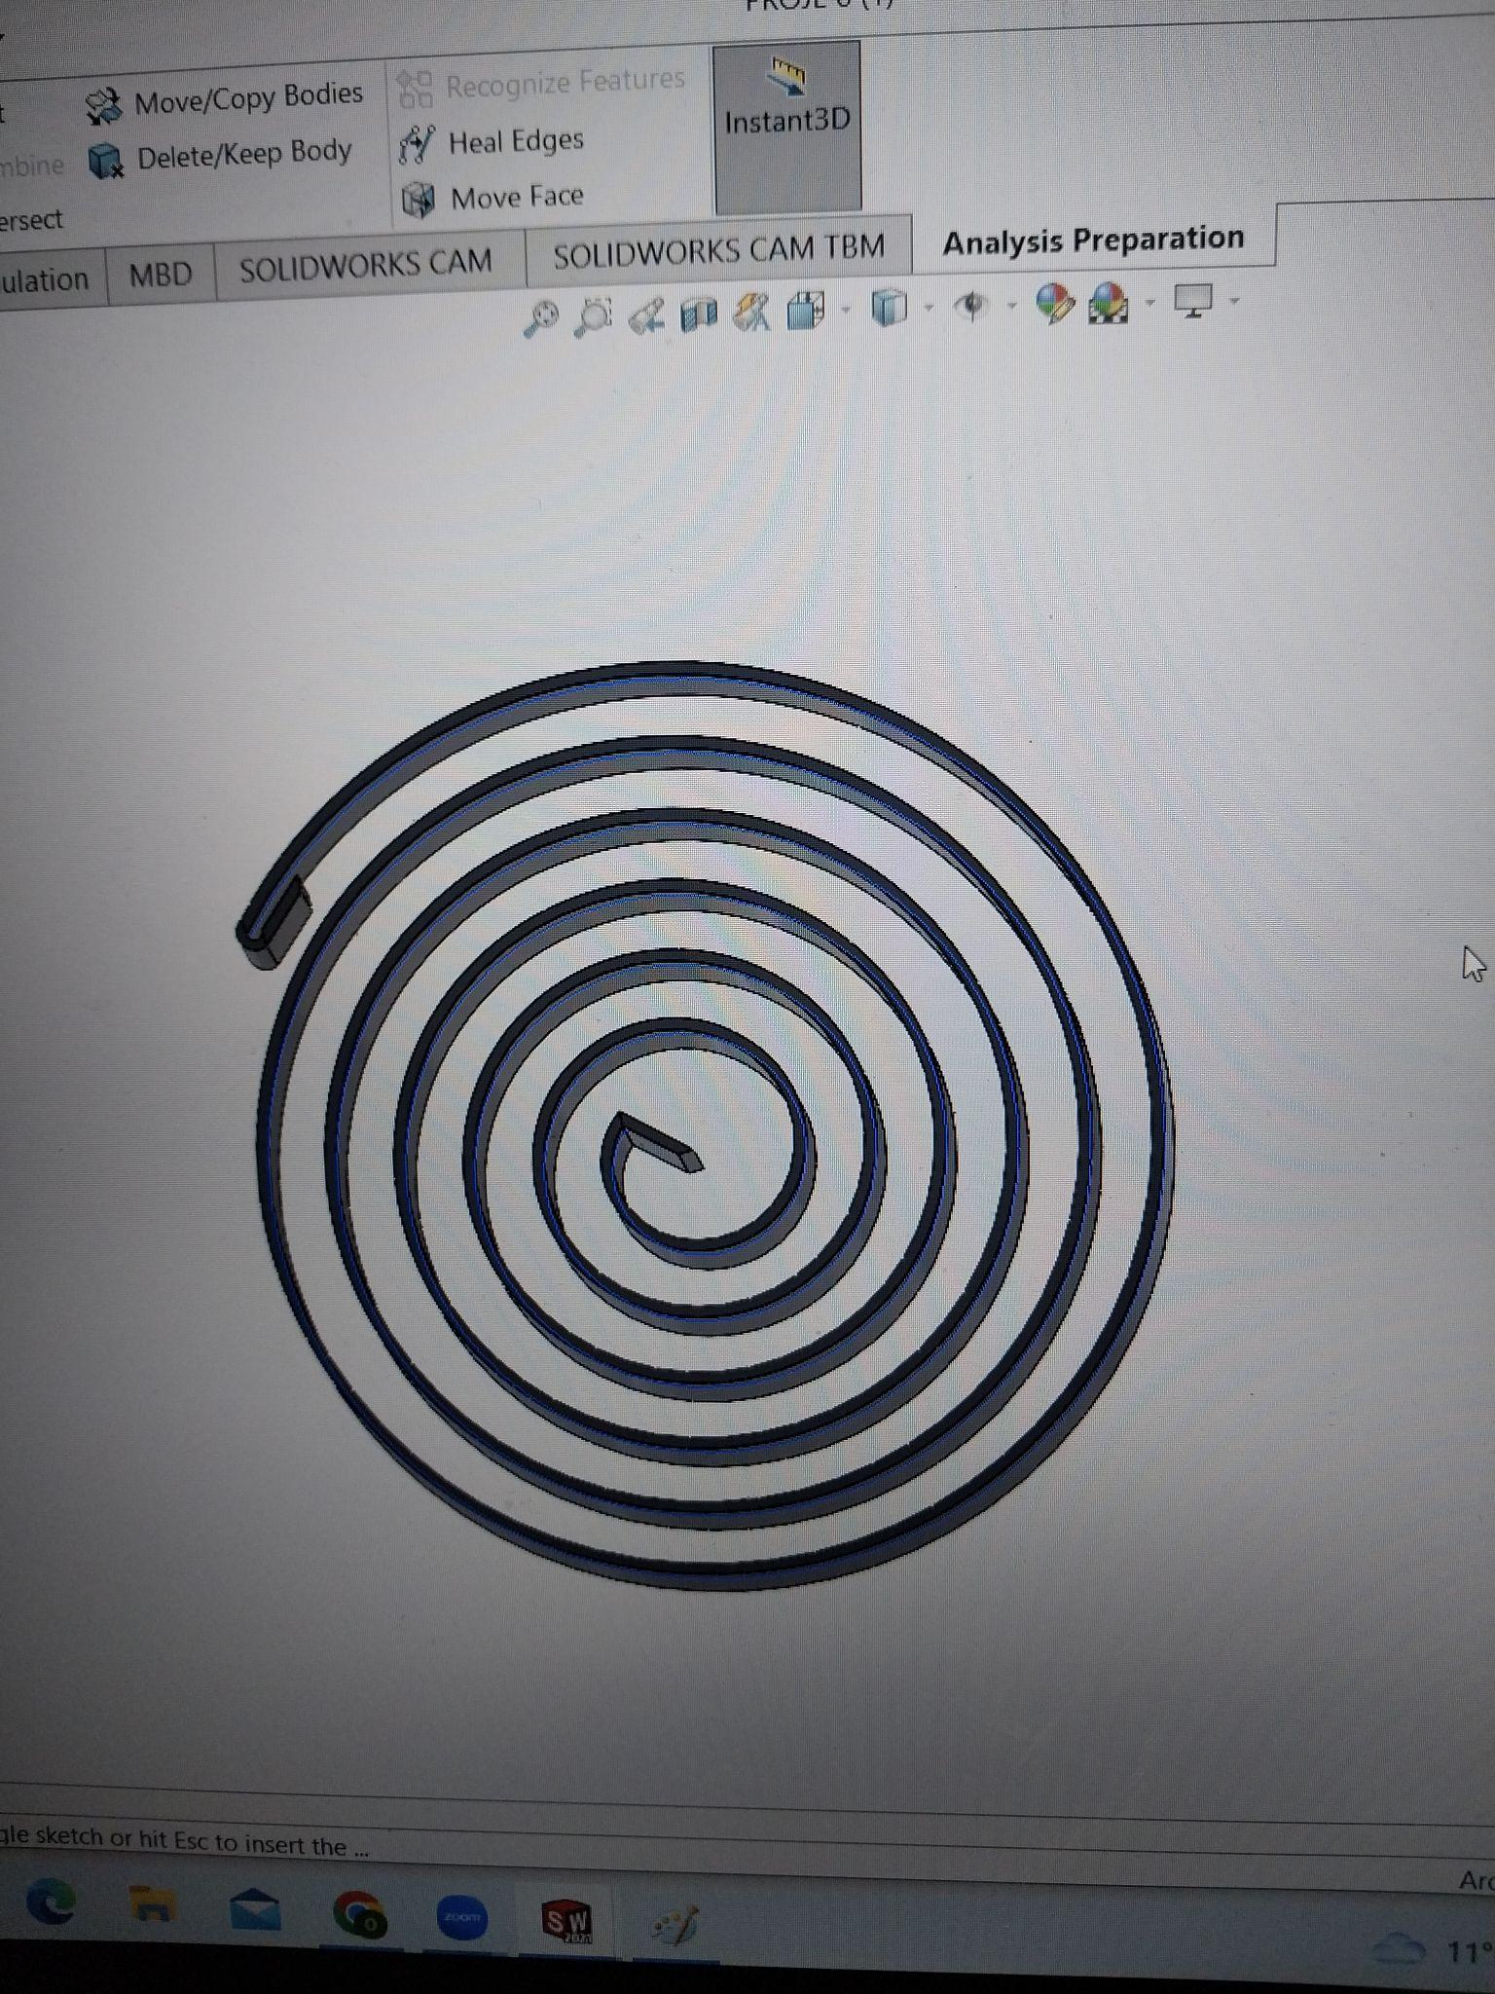

**WHEELS**

Wheels served as a means between car and ground. It transforms the engine’s ( in this case gearbox) power into turning motion and creates movement.

12) Wheel

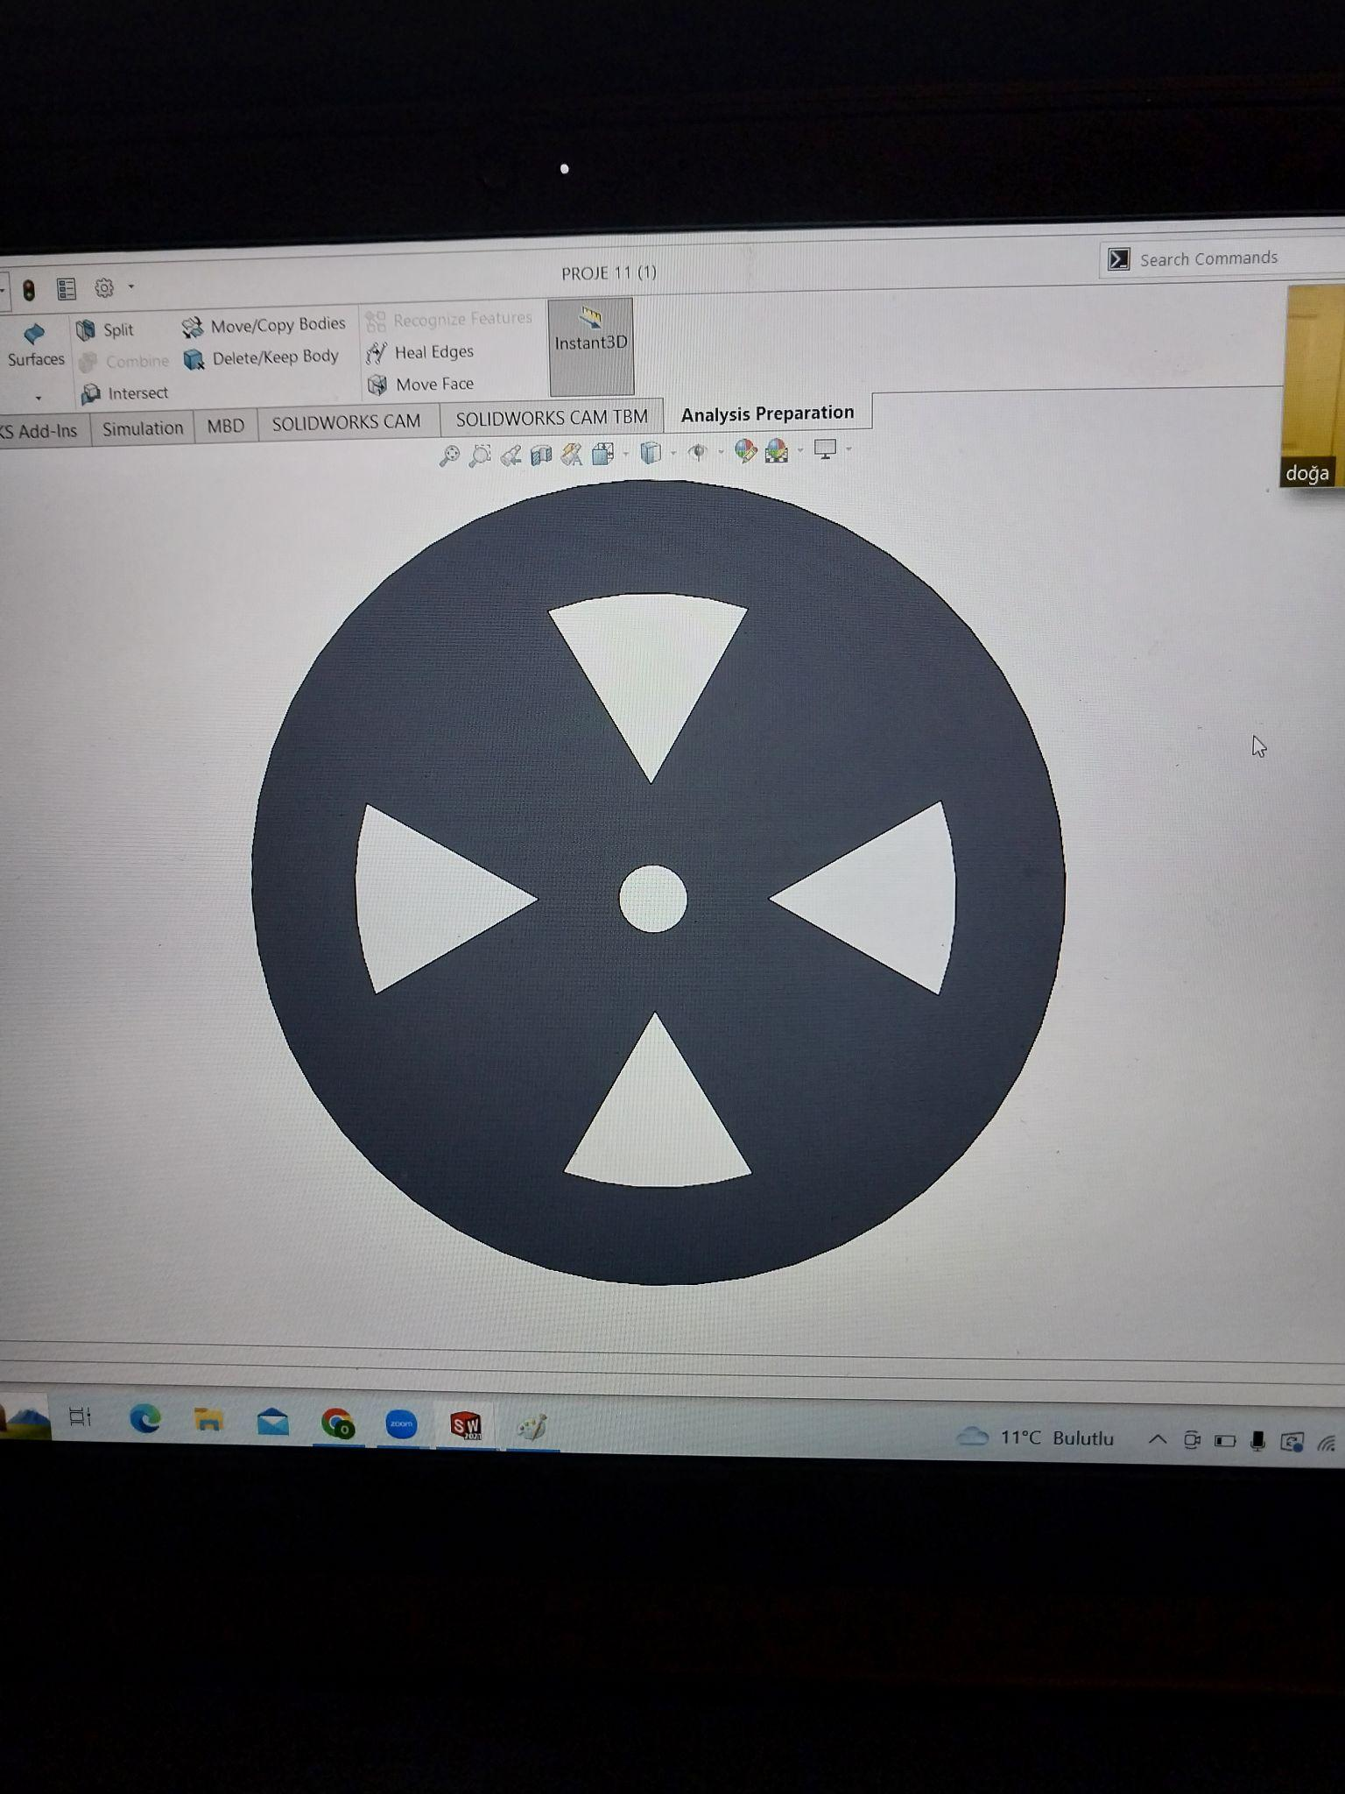

**Dissection Plan:**

We divided the body into the upper and lower body instead of 6 different bodies from different perspectives. Moreover, We add minimum details to bodies. For example, we didn’t include side mirrors, car hood, spoiler, doors, etc. For the gearbox of the car, we made 3 unique motor parts to create a big motor with 5 gears and 1 coiled spring inside. The design of the gearbox can be further detailed by adding more gears, coiled springs, and different motor parts. Lastly, wheels are designed as one single component instead of a rim and wheel by using different materials.

**Hand-Drawn Sketches:**

**MOTOR PARTS**

Motor Part 1

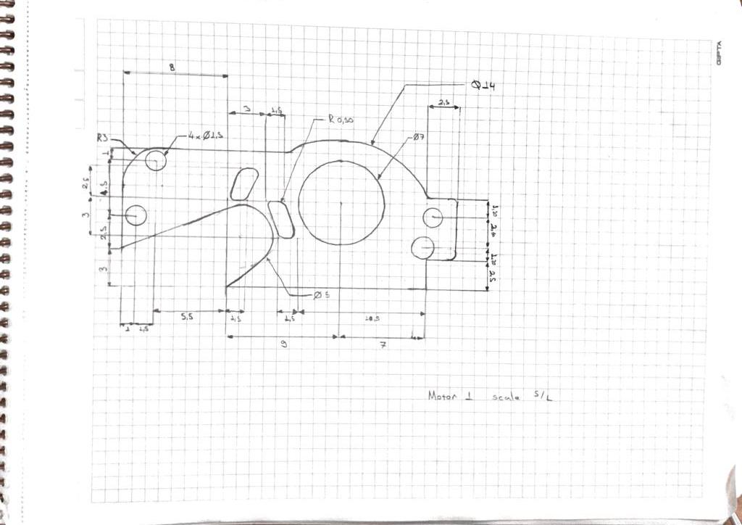

Motor Part 2

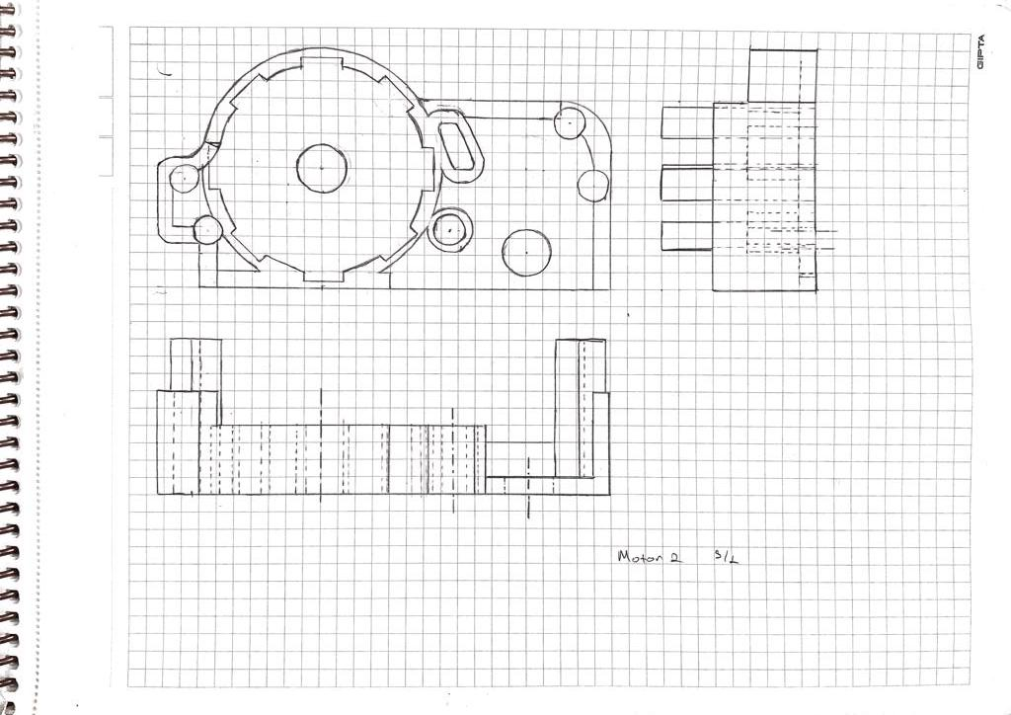

Motor Part 3

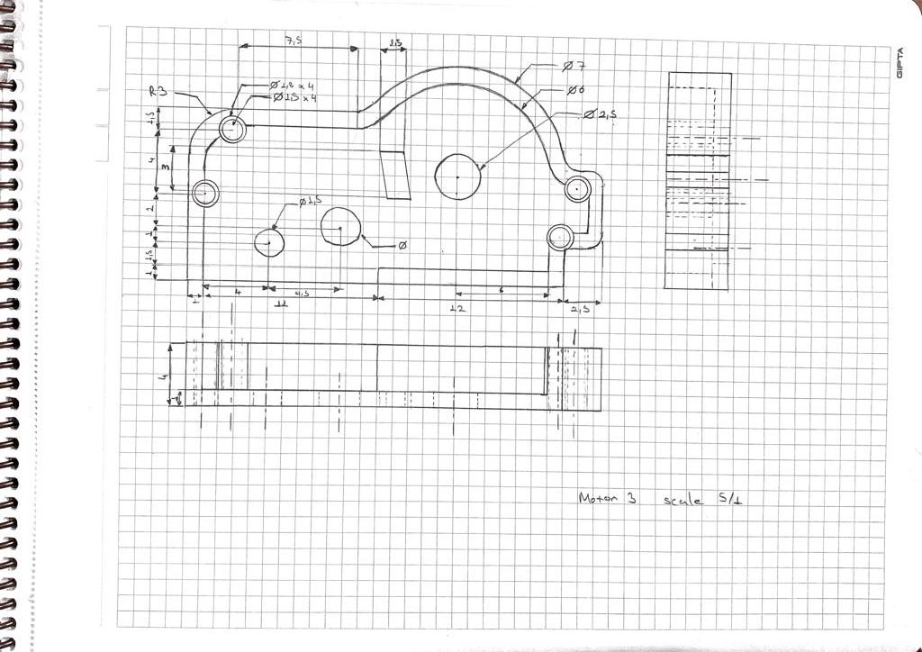

**GEARS**

Gear 1

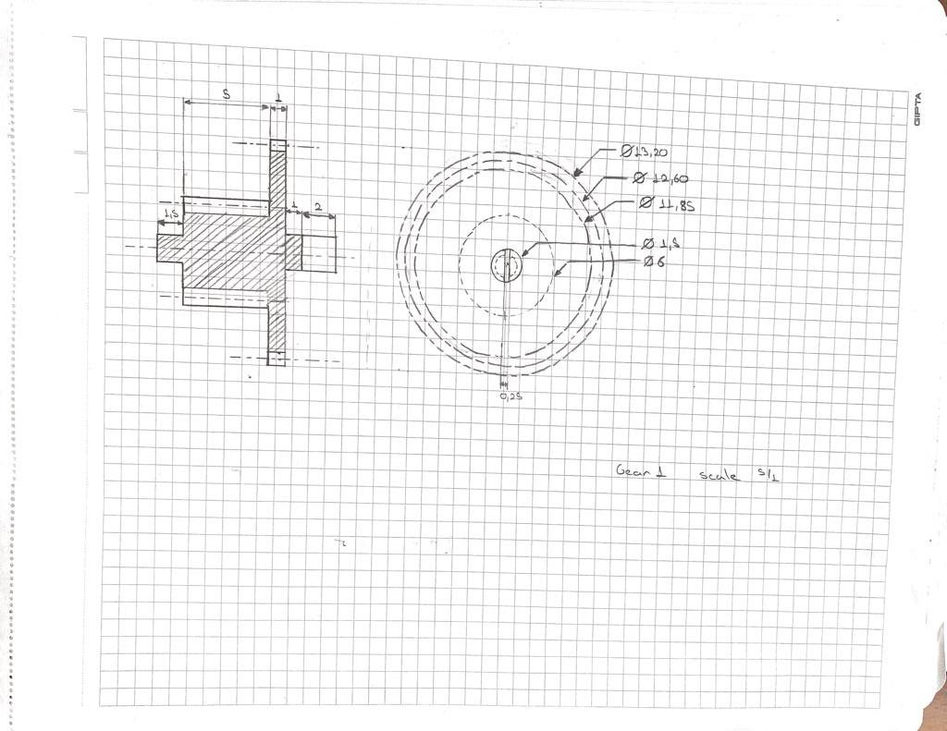

Gear 2

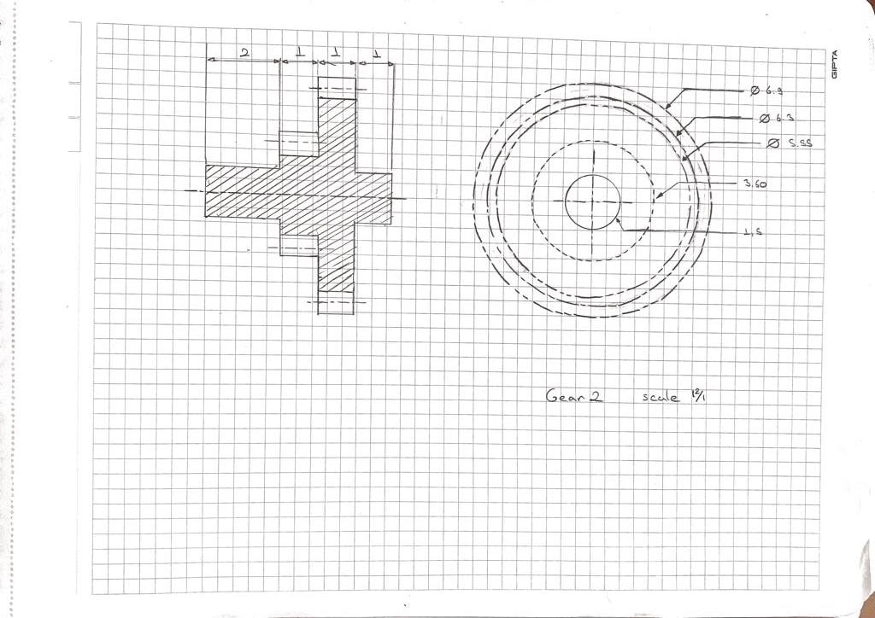

Gear 3

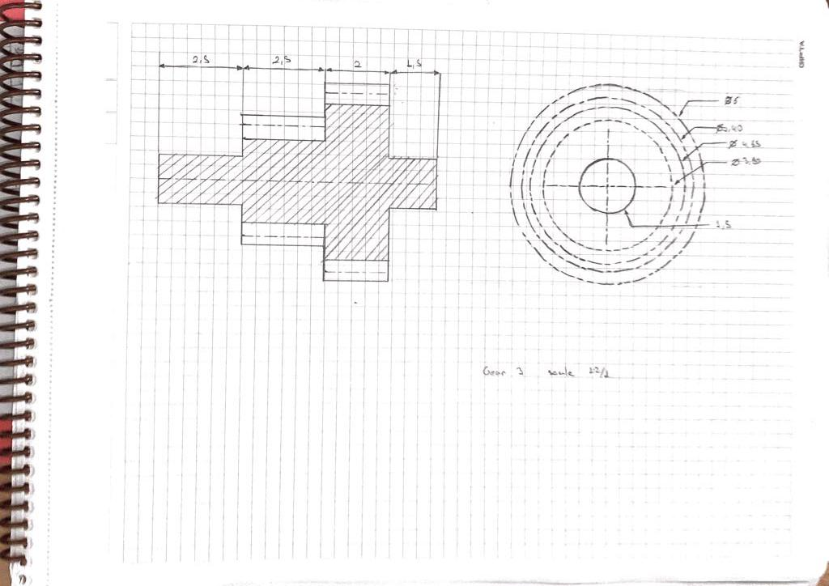

Gear 4

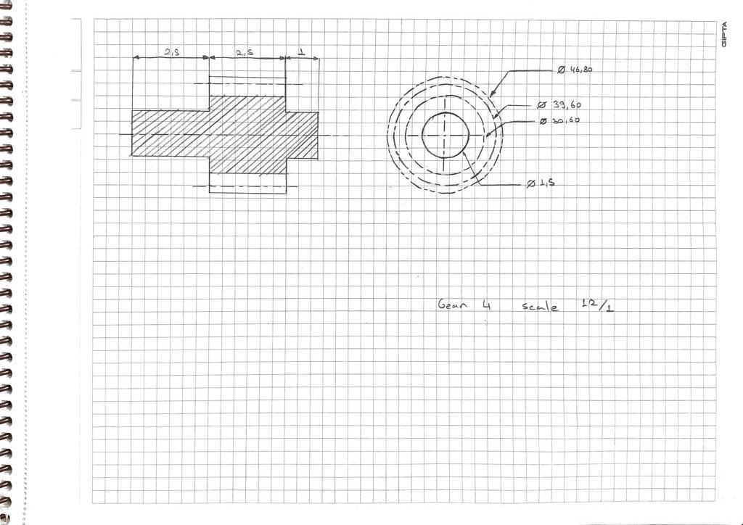

Gear 5

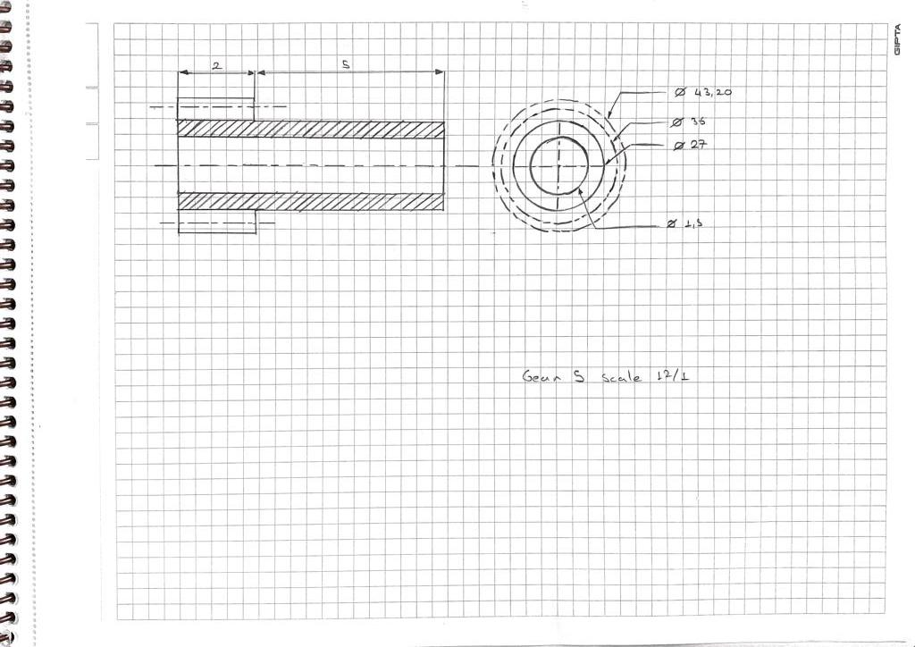

**WHEEL**

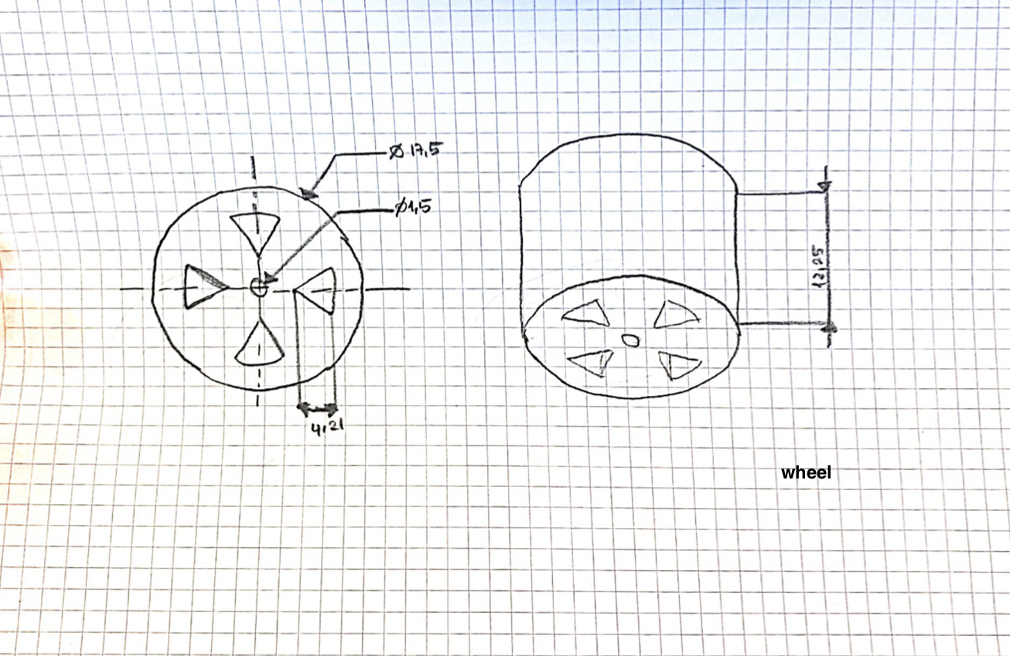

**BODIES**

Upper body

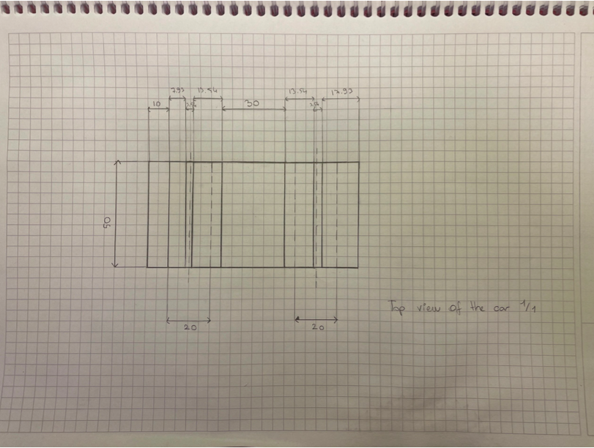

Lower Body

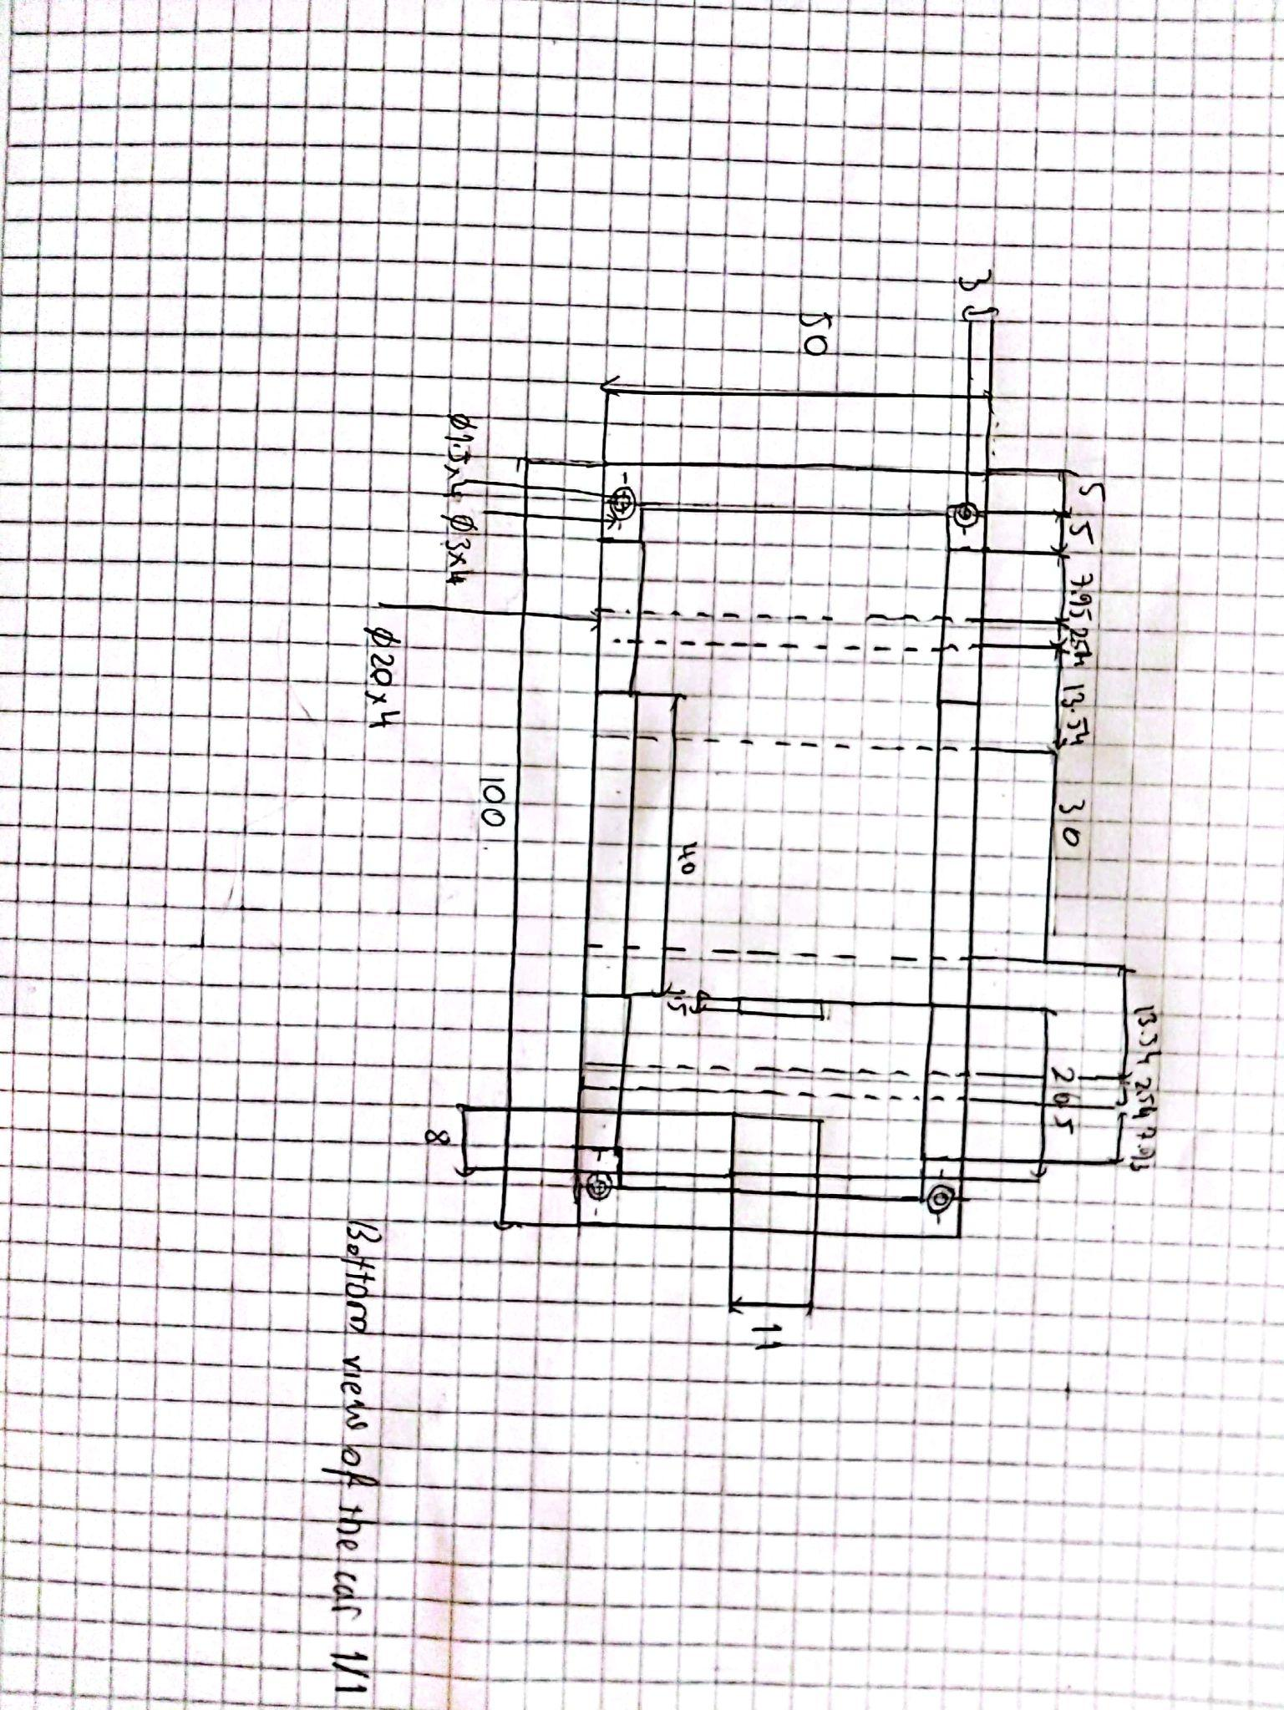

**Planned Work Distribution Table:**

| **Work** | **Week** | **Member** |
| --- | --- | --- |
| Project Progress Report | 9 | All team members |
| 3D Drawing of Components | 10 | All team members |
| Assembling of All Components | 11 | All team members |
| Project Final Report | 12 | All team members |

**References:**

DG Enterprise and Industry (2013), Study on the competitiveness of the toy industry, ECSIP consortium.

Shirbon, E. (2009, August 14). *Da vinci's lion prowls again after 500 Years*. Reuters. Retrieved December 4, 2022, from <https://www.reuters.com/article/us-france-davinci-lion/da-vincis-lion-prowls-again-after-500-years-idUSTRE57D1MQ20090814>

Sorrel, C. (2011, April 11). *It's a wind up: Gorgeous Spring-powered toy car not for kids*. Wired. Retrieved December 4, 2022, from <https://www.wired.com/2011/04/its-a-wind-up-gorgeous-spring-powered-toy-car-not-for-kids/>

Wulffson, D. (n.d.). *One more step*. archive.ph. Retrieved December 4, 2022, from https://archive.md/20121209181102/http://webcache.googleusercontent.com/search#selection-33.0-47.10